MSMA Program

Project 2

Pricing Analytics

Yuying He

Zheng Lian

Yingluo You

Tianyao Liu

Jing Zou

**Question 3. Logit Model without Segmentation**

**3.1 Elasticity**

Working with average price, we calculated purchasing probability for each product, then calculated their own elasticity. The own-price elasticity of KB is -4.257827, KR is -4.13127 and MB is -4.069547, which means consumer demands of these product are sensitive to price change. Among these three products, KB’s demand is more sensitive than KR, and KR is more sensitive than MB.

The cross-price elasticity of KR’s price change to KB’s and MB’s demand change is 1.019923, KB to KR and MB is 0.9054743 and MB to KB and KR is 0.9601564. This means that KR & KB, KR & MB are closest substitutes.

Considering both own elasticities and cross elasticities, KB’s consumers are the most price-sensitive ones. But when Kiwi raising the price of KB, it’s less likely for KB customers to switch to KR and MB.

Above results may not be reasonable mainly for below reasons: Firstly, as Kiwi bubble hasn’t been launched yet, the estimation of price elasticity and influence may not reflect the real business world. Secondly, our calculation of elasticity is based on whole customer group without segmentation. These could also influence the result accuracy. Lastly, it’s reasonable that KB are less to be replaced by MB and KR because Kiwi has better brand image than mango and ‘bubbles’ is the best characteristic of soft drink.

|  |  |
| --- | --- |
|  | Elasticity Without Segmentation |
| KB own | -4.257847 |
| KR own | -4.13127 |
| MB own | -4.069547 |
| KR-KB cross | 1.019923 |
| MB-KB cross | 0.9601564 |
| KB-KR cross | 0.9054743 |
| MB-KR cross | 0.9601564 |
| KB-MB cross | 0.9054743 |
| KR-MB cross | 1.019923 |

**3.2 Optimal (Profit Maximization) Price**

Given MB’s price ($1.43) and the demand and profit function we defined , the optimal prices of KR and KB are specifically $1.2 and $1.2. In this case, the maximized profit for Kiwi is $391.73, which is the sum profit of KR and KB.

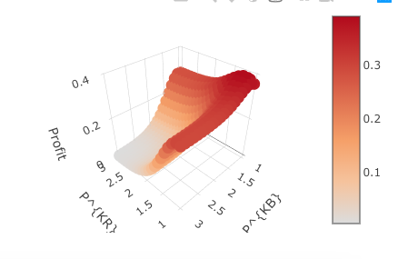

**Question 4. Logit Model with Segmentation**

**4.1 Clustering Segmentation**

Firstly, we test 4-9 clusters to decide the optimal number of clusters. If we use fewer clusters like 4 or 5 clusters, plotted lines are duplicated and are not enough to reflect the separate customers. While too many clusters like 9 clusters will make the model more flexible, but the estimated parameters become less reliable and each segment size gets too small.

6 clusters and 7 clusters all fit customers segmentation, but considering reliability and flexibility trade-off, we choose 6 clusters. Thus, for each segment, there are enough customers so as not to weaken reliability.

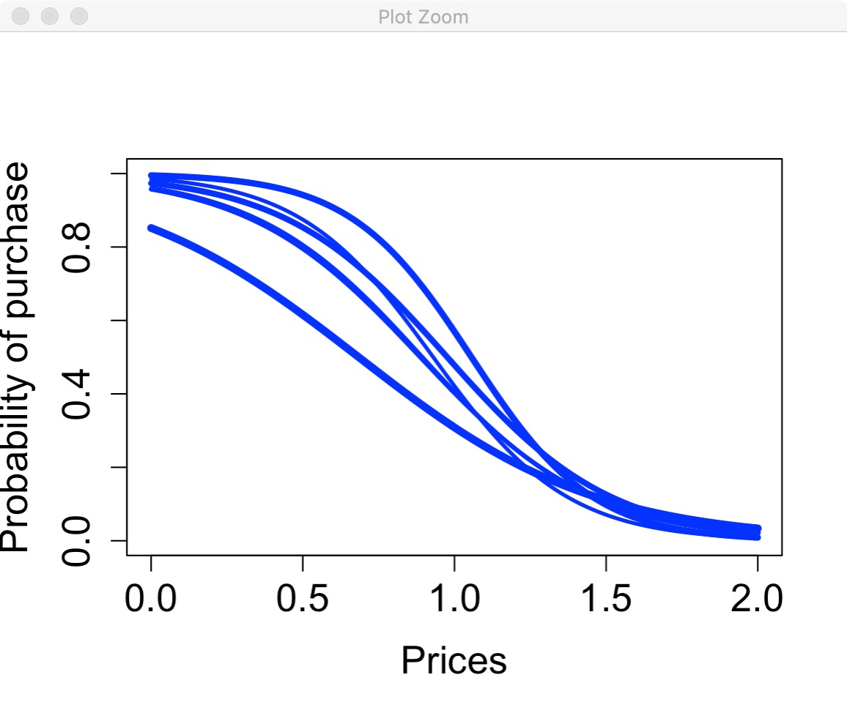

Then we use 6 clusters to calculate coefficients for each segment. Here, segment 7 is denoted by NA, so we get 6 segments in all.

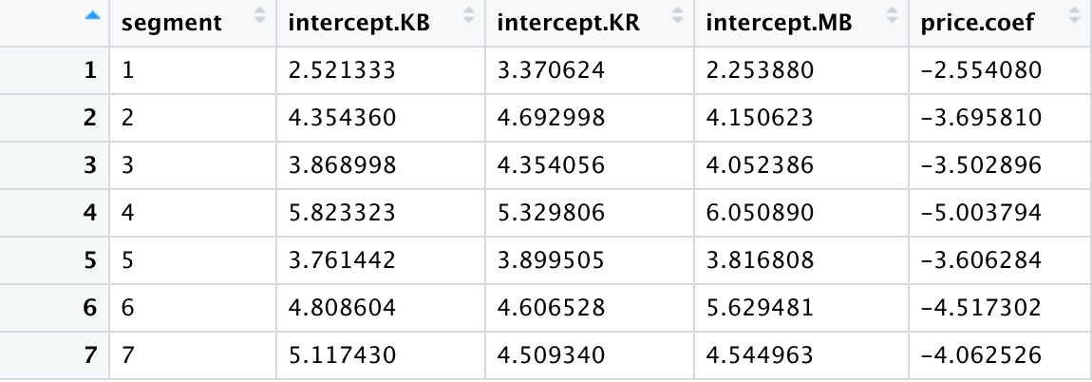

(from the coefficients: segment 7 like KB the most.

Segment 1,2,3,5 like KR most, in which only segment 2 prefer KB than MB.

4 of 7 segments prefer KR than KB,

segment 4, 6 like MB the best, in which both segments prefer KB than KR).

**4.2 Elasticities**

**4.2.1 Own Elasticities and Cross Elasticities**

|  |  |
| --- | --- |
|  | Elasticity With Segmentation |
| KB own | -4.286751 |
| KR own | -3.495968 |
| MB own | -4.078755 |
| KR-KB cross | 1.016185 |
| MB-KB cross | 1.01548 |
| KB-KR cross | 0.7162632 |
| MB-KR cross | 0.8204181 |
| KB-MB cross | 0.8127758 |
| KR-MB cross | 0.9320796 |

After segmentation, KB’s own-price elasticity is -4.286751, KR’s is -3.495968 and MB’s is -4.078755. KB’s cross elasticity with KR is -0.7162632, with MB is -0.8127758; KR’s cross-price elasticity with KB is -1.016185, with MB is -0.9320796; MB’s cross-price elasticity with KB is -1.01548, with KR is -0.8204181.

**4.2.2 Comparison with Non-segment Situation**

|  |  |  |
| --- | --- | --- |
|  | Elasticity Without Segmentation | Elasticity With Segmentation |
| KB own | -4.257847 | -4.286751 |
| KR own | -4.13127 | -3.495968 |
| MB own | -4.069547 | -4.078755 |
| KR-KB cross | 1.019923 | 1.016185 |
| MB-KB cross | 0.9601564 | 1.01548 |
| KB-KR cross | 0.9054743 | 0.7162632 |
| MB-KR cross | 0.9601564 | 0.8204181 |
| KB-MB cross | 0.9054743 | 0.8127758 |
| KR-MB cross | 1.019923 | 0.9320796 |

From the table above we could clearly compare elasticities with and without segmentation. Compared with non-segment case, KB and MBs’ own-price elasticities become greater negative slightly, which means with segmentation, customers among 6 segments are more price sensitive to KB and MB. While KR’s own-price elasticities become less negative, this shows that customers among 6 segments are less price sensitive to KR and are less likely to switch to other products. From the perspective of own-elasticity, segmentation reflects more precise and more concentrated preferences for each segment.

Except MB-KB pair, other cross-price elasticities all decrease.This means price increase of one product will less affect the choice probability of another product to decrease, that is to say, substitutive effects between two products decrease because of each segment’s higher loyalty towards certain product. Thus, our segmentation reveals each segment’s discrete preferences.

**4.2.3 Substitution Pattern**

We can compare the absolute value of all cross elasticities to determine which two products are closest substitutes. After conducting segmentation, KR-KB cross elasticity (1.016185) is the biggest one among all cross elasticities. This reflect that Kiwi Bubble and Kiwi Regular are closest substitute.

However, KB-KR cross elasticity is the smallest one (0.7162632). The difference between KR-KB and KB-KR is because that the effect of KB’s price change on KR’s demand change is smaller than the effect of KR’s price change on KB’s demand change.

**4.3 Customer Segmentation and Product Positioning**

We drew two scatterplots based one each segment’s B0 on KB, KR, and KB to see how much each segment of consumers prefers KB over the other two. Based on the result, we can tell that segment 2,3 have higher tendencies towards product KB over MB. Also we found out that segment 1 and segment 6 prefer KB over KR. It is also worth for us to know that in segment 4 and segment 6, the preferences of KB and KR are close.

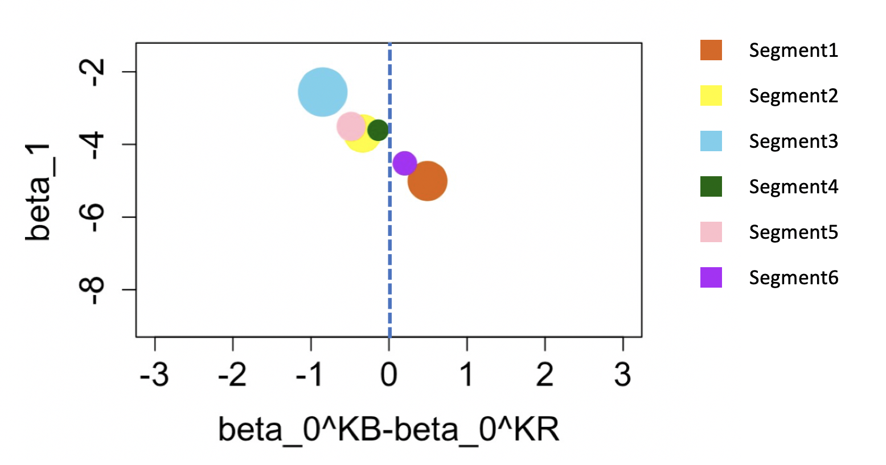

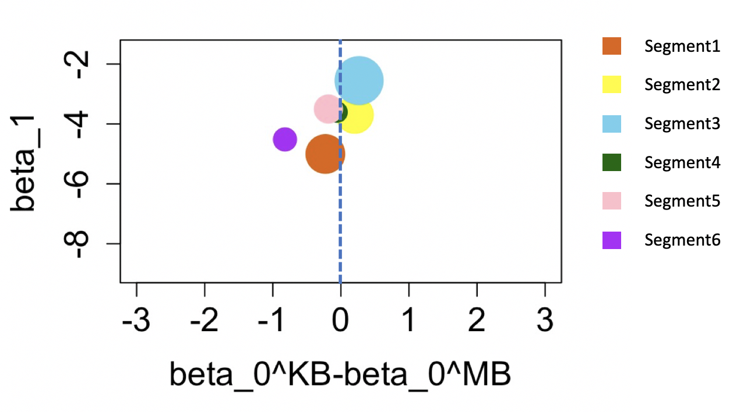

By studying the Beta0 of segments on three products, we could say that segment 1,2,3,5 like KR most, segment 4 and 6 like MB most. Also from this chart we can see that in almost all segments except segment 6, the preferences of KB and MB are almost the same.



After that, we calculated each segment’s profit if launching product KB to see that which segment have higher possible profit. Based on the summary below, segment 1 and 5 have higher profits compared with other segments.

|  |  |  |
| --- | --- | --- |
|  | **PriceKB** | **ProfitKB** |
| **1** | 0.99 | **56.41933** |
| **2** | 0.98 | 21.62776 |
| **3** | 1.05 | 37.82587 |
| **4** | 0.99 | 29.18509 |
| **5** | 1.01 | **44.77759** |
| **6** | 0.94 | 25.82988 |

Overall, we recommend Kiwi to position KB to target segment 1 and 5, especially 1, which prefers KB over KR, generates highest profit ($56.41933) and occupies highest market share (24.4%).

**4.4 Situation Comparison (With Segmentation)**

**4.4.1 Situation 1: Not Launching KB**

We used two strategies to deal with situation without launching KB.

In first strategy, we don’t use existing coefficients and find out new coefficient with adjusted data. We deleted kiwi bubble column and delete the row in which customers selected KB. Then we construct new coefficient estimation and KR demand function given new dataset. After constructed new KR aggregate choice, we calculated the profit of KR without launching of KB, which get optimal price as $1.06 and profit as high as $317.4755.

In second strategy, we keep existing coefficients and only deal with new demand function and new aggregate choice probability. In this way we find out that the best price is $1.07 and get the highest profit as $295.7271.

In second strategy to get more accurate MB product profit, as mango’s price don’t react to the change of kiwi price, we constructed new demand and aggregate choice function for mango and calculated mango profit as $109.7806 when price is $1.43.

Finally we choose the second strategy for further analysis because the delete of product KB may cause less customers in reacting with final choice.

**4.4.2 Situation 2: Launching KB**

Now we have 3 products in the market. With the price of MB being fixed at $1.43, Kiwi need to determine the prices of both KB and KR, to maximize the aggregated profit.

We explored the different combinations of priceKB and priceKR within a reasonable range from $0 to $2, and calculated their profit under each pricing scenarios.

Finally, the profit could be maximized at $424.4603 when Kiwi set price of Kiwi Bubble as $1 and set price of Kiwi Regular as $1.3 when mango price equals to $1.43. The profit of mango would be $85.3327.

**4.4.3 Comparison**

* with/without KB

|  |  |  |
| --- | --- | --- |
|  | **Without KB** | **With KB** |
| **PriceKB** | NA | 1 |
| **PriceKR** | 1.07 | 1.3 |
| **PriceMB** | 1.43 | |
| **Profit KB+KR** | 295.7271 | 424.4063 |
| **ProfitMB** | 109.7806 | 85.3327 |

Compared with above chart, we can find out the price increases with the launch of Kiwi Bubble, and the profit also increases 43% to $424.4063. The profit of MB decreased after KB’s launching. This means that Kiwi would be able to seize their customers (and profit) by better product mix. In this way, we would be able to grab more market share as well.

* with/without segmentation

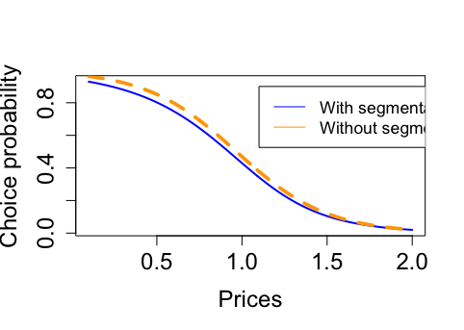

As long as we apply segmentation, the optimal price of KB decreased from $1.2 to $1. Because we calculated the cluster share after segmentation to calculate aggregated choice and profit, the lower price implies that among total market, segments not loving KB (willingness to pay below average) take bigger shares than segments loving KB. As a result, it is necessary for Kiwi to implement second degree price discrimination on different segments. For example, giving coupons to those clusters whose willingness to pay for KB is relatively low.

**Question 5. Understanding Strategic Responses**

**5.1 Mango’s Optimal Price**

Till now, we assume that the competitor MB would not react to KB and KR price change, but remain the price at $1.43. However, in reality, the competitor will react and reset their own optimal price to compete with us.

According to our analysis above, under the situation where price MB is $1.43, we got the maximum profit of Kiwi as $424.4063. The optimal price of KB and KR are $1 and $1.3, respectively. Then we used KB’s and KR’s optimal prices to calculate Mango’s optimal (profit maximizing) price. Under the situation where priceKB=$1 and priceKR=$1.3, we can get the maximum profit of Mango as $171.3624, and the optimal price of MB as $0.95.

|  |  |  |  |
| --- | --- | --- | --- |
| opt Price KB | opt Price KR | opt Price MB | Max(ProfitMB) |
| 1 | 1.3 | **0.95** | 171.3624 |

**5.2 Nash Equilibrium**   
**Iteration 1**

Kiwi needs to react to Mango’s new price. We then set new optimal prices for KR and KB to respond to the new price of Mango Bubble that we just derived. As the price of MB is $0.95, we then ran the profit functions of KB and KR according to their own aggregate choice. The new optimal price are $1 and $1.2.

|  |  |  |  |  |  |
| --- | --- | --- | --- | --- | --- |
| num.Round | opt price KB | opt price KR | opt Price MB | Max(Profit Kiwi) | Max(ProfitMB) |
| Round 0 | 1 | 1.3 | **0.95** | 424.4063 | 171.3624 |
| Round 1 | **1** | **1.2** | 0.95 | 282.6778 |  |

**Iteration 2**

Mango then detected Kiwi’s price change again and will react to this optimal price of price KB and KR which are $1 and $1.2. We used the aggregate choice probability of MB and got the maximum profit of MB this time as $163.5036 and the optimal price as $0.94.

|  |  |  |  |  |  |
| --- | --- | --- | --- | --- | --- |
| num.Round | opt price KB | opt price KR | opt Price MB | Max(Profit Kiwi) | Max(ProfitMB) |
| Round 0 | 1 | 1.3 | **0.95** | 424.4063 | 171.3624 |
| Round 1 | **1** | **1.2** | 0.95 | 282.6778 |  |
| Round 2 | 1 | 1.2 | **0.94** |  | 163.5036 |

**Iteration 3 & Iteration 4 & Iteration 5**

As Mango would change its price to $0.94, Kiwi would soon responds to this price change and adjusts product price of KB and KR. Finally, the MB price will be 0.92 and KB price will be 0.9 and KR price will be 1.2.

|  |  |  |  |  |  |
| --- | --- | --- | --- | --- | --- |
| num.Round | opt Price KB | opt price KR | opt Price MB | Max(Profit Kiwi) | Max(ProfitMB) |
| Round 0 | 1 | 1.3 | **0.95** | 424.4063 | 171.3624 |
| Round 1 | **1** | **1.2** | 0.95 | 282.6778 |  |
| Round 2 | 1 | 1.2 | **0.94** |  | 163.5036 |
| Round 3 | **0.9** | **1.2** | 0.94 | 283.9205 |  |
| Round4 | 0.9 | 1.2 | **0.92** |  | 144.9402 |
| Round5 | **0.9** | **1.2** | 0.92 | 280.217 |  |

As we can see from the iteration charts, the optimal prices of KB and KR of iteration 5 finally remains the same as iteration 2, which means the ‘price war’ between Kiwi and Mango sides converate at the ‘equilibrium price’. In other words, these two companies both achieve to the Nash Equilibrium.

In conclusion, after we do the five rounds of ‘optimal price war’, Kiwi and Mango both get their optimal outcome and there is no incentive for them to change to other prices. Overall, Kiwi and Mango can receive no more incremental profit from changing price again, and also they assume the competitor remains constant in their price.

**5.3 Strategic Advantage of Kiwi Bubbles at the ‘Price War’**

In order to compare the difference of the situation between existence of KB or not, we do the ‘price-war’ between only product KR and MB. After doing three rounds optimal prices change of KR and MB correspond to each other’s price, we finally get the Nash Equilibrium between only KR and MB. As we can see from the chart below, the profit of Kiwi achieves to 201, the price of KR and MB are respectively $1 and $0.97.

Comparing without-KB chart to KB-launched chart, obviously, the price of final optimal KR increases from $1 to $1.2and the price of final optimal MB decreases from $0.97 to $0.92. The profit of Kiwi increases from $201 to $280.217, which means that with KB launched, Kiwi will get more profit from the market while Mango will share this part of profit with KR.

After launching the new product KB, the final optimal prices of Kiwi’s products increase, which means the KiWi get more market share. The market is not saturated before the launch of KB, some segments of customer may not choice either KR or MB or they may not satisfied with the price of KR or MB. As the KB launched at this price, this part of customer targeted properly and make the market more saturated. Kiwi side can get more profit with the earning more customers. Furthermore, as Kiwi get more market share, the difficulty of new entrance also increase.

|  |  |  |  |  |
| --- | --- | --- | --- | --- |
| num.Round | opt Price KR | opt Price MB | Max(Profit Kiwi) | Max(ProfitMB) |
| Round 0 | 1.07 | **0.99** | 424.4063 | 200.1767 |
| Round 1 | **1** | 0.99 | 206.6413 |  |
| Round 2 | 1 | **0.97** |  | 183.5248 |
| Round 3 | **1** | **0.97** | 201 |  |

With new product as KB having lower price than KR, kiwi is able to have two product line for different segment customers with different needs in price.

In a word, we should launch Kiwi Bubble in Kiwi in order to gain higher market share as well as consistent brand image, which benefits Kiwi’s long-term profit.